1. Program is implemented and tested on python version 3.5+
2. The code uses following libraries:
   1. Flask
   2. Nltk
   3. Pandas
   4. Sklearn
   5. Keras
   6. Tensorflow
3. Code is commented
4. When you run the code, you can access the API from web
5. 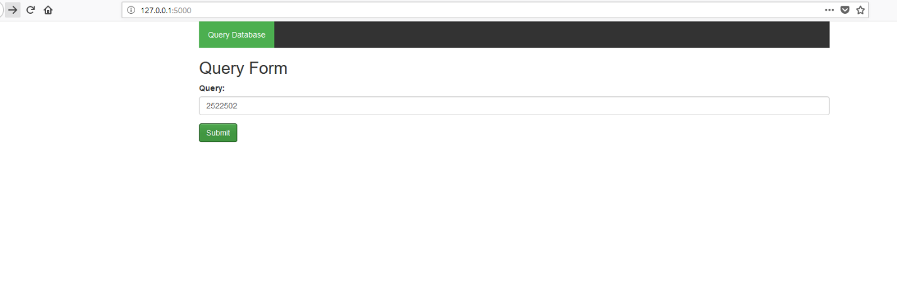Put ID of the posts, against which you want to get similar posts.
6. Result would be displayed as json response (Result attached as an image)